I. Maze
Consider the maze shown in the figure below. S is the initial state and G is the goal state. Dark squares are blocked cells. All squares, except for the start and goal states, are labeled, with row and column numbers. For example, n54 is the cell in the fifth row, fourth column.
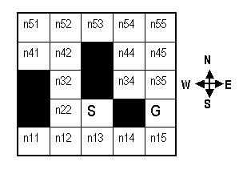
For all the questions in this problem:
- the graph states are the squares of the maze.
- there are links along the cardinal compass directions to neighbouring squares (that are not blocked). That is, diagonal moves are not permitted, nor are moves into or across a black square.
- the successors of a state are to be generated in a FIXED order to be drawn from left to right, namely N, E, S, W.
We say that a state is expanded when a path to that state is pulled off of Q.
For Breadth-First search (with a Visited List), indicate the order in which states are expanded. Enter a sequence of state names starting with S and ending with G, e.g. S n13 n22 ... G.
II. Maze problem, the sequel
Solve the same maze problem defined in section I but using the following algorithms:
- A* algorithm with the Strict Expanded List, and the Manhattan distance heuristic.
- IDA* and the Manhattan distance heuristic
III. A* with the Non-Strict Expanded List
Consider the graph below with a list of heuristic values and path lengths. One of these heuristics is not consistent (as defined in the lecture). Simulate A* with the non-strict expanded list and show that A* is able to recover from this inconsistency problem by storing more information about the expanded nodes and using that information for recovery.
Hint: In the Expanded List column of your simulation, record the actual node and path length of each expanded state.
